The battery cannot start

Author:胡心怡
Reviewer：Eason

FAQ\ BAT
Issue introduction
After the battery is installed, it cannot be turned on, and the button does not respond.
Confirmation of basic information
[Photo]SN numbers of inverter and batteries.
Guidance for installer
Step1: Restart the battery correctly to see if it’s back to normal.
For T58: According to the following rules, dial the DIP switch to the correct number of normal connection use based on the actual number of batteries, then move the circuit breaker switch to “ON” and press the power button to start the battery. Remember to short-circuit the last battery.
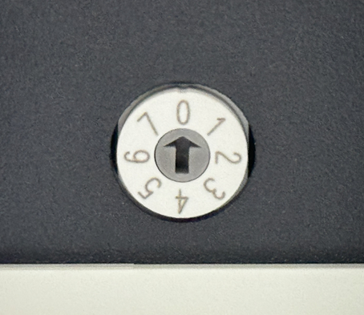
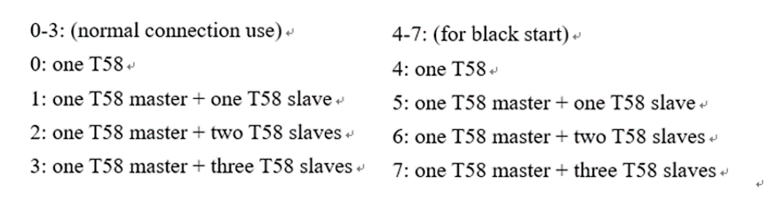
For T30：Move the circuit breaker switch to “ON” and press the power button for three seconds. When you hear the ‘Click’, the batteries have started successfully.
Step2: Check the connection of power cables and every terminal of batteries. Ensure that the cables are connected correctly and that the terminals are not damaged.

X plug of T58 | Y plug of T58 | Power terminal of T30
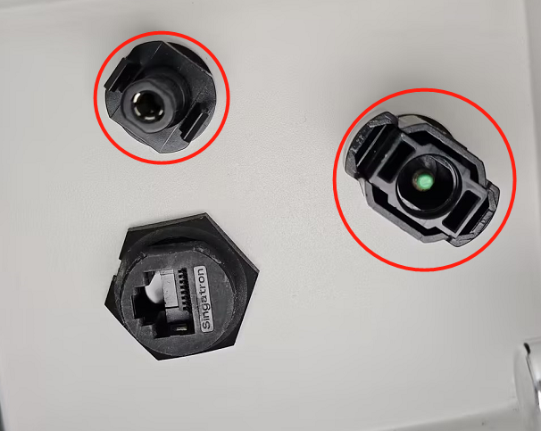 | 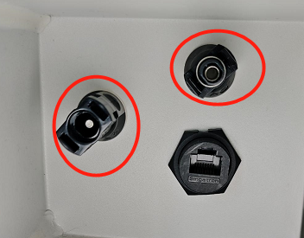 | 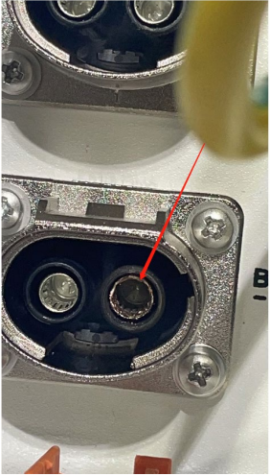
Step3:Measure the voltage of each battery.
Measure the voltage of T58 | Measure the voltage of T30
Use the red pen and black pen of the multimeter to measure whether the voltage on the battery side is normal.Normal single T58 battery has a rated voltage of 115.2V, the operating voltage range of 100-131V.  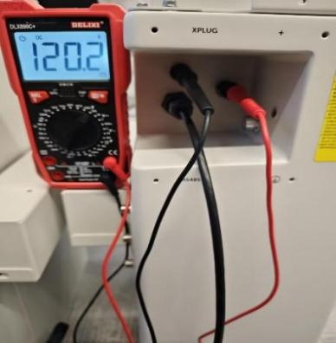 | Use the same method to measure the voltage of T30, insert the pen into the round hole to the right of the terminal. A normal T30 single battery has a rated voltage value of 102.4V and the operating voltage range of 90-116V.  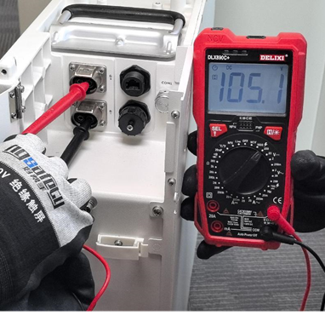
Step2：If the voltage of each battery is above 40V and the total system battery voltage meets the inverter's minimum battery voltage requirement, use the inverter's force charging mode to recharge the batteries.
Setting path: Work mode→Work mode→Manual→Force charge
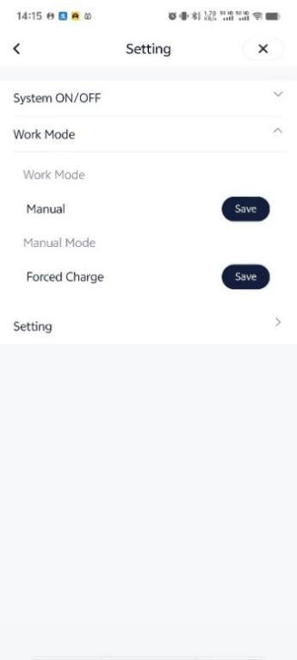
If the inverter is unable to complete force charging, and the voltage of a single battery is already below 40V, please refer to the attached T-BAT Charger user manual to perform forced charging on the battery.
https://km.solaxpower.com/index.html#doc/enterprise/362472
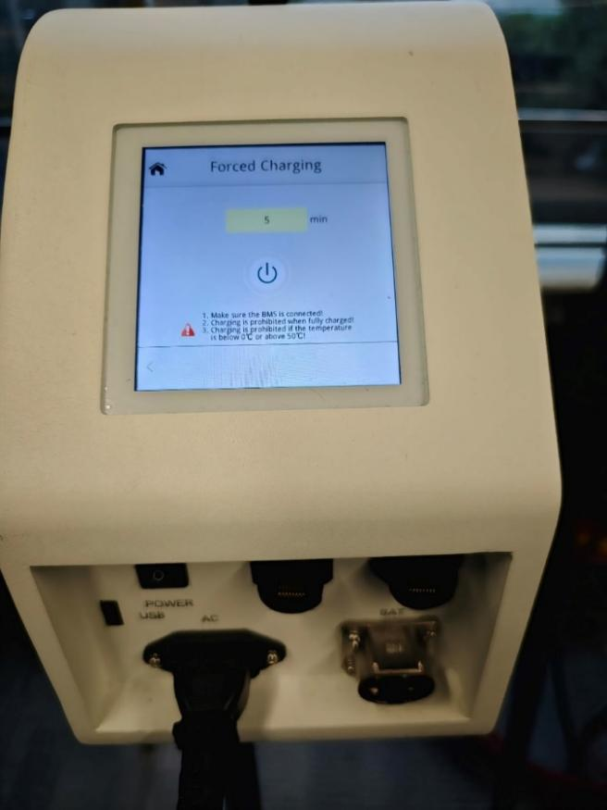

If one battery is still in low voltage after being charged, remove it then connect other batteries and start the system to ensure system running properly.
For T30, if the voltage is normal, try to activate the battery through PV. When the system is on grid, disable the charge from grid.
Setting path: Setting→User settings→Self Use→Charge from grid→Disable
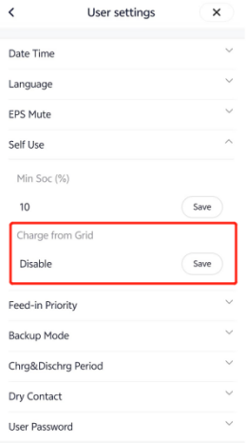
Then wait for PV voltage to increase to startup voltage, if batteries could turn on normally, it indicates a faulty switch in the BMS, so replace the BMS.
Step4: Upgrade battery and inverter to the latest firmware version, then restart the batteries.
Information check list
If you have completed the above <Guidance for installer>, and the problem is still not solved, please collect the following troubleshooting information and send them to the R&D.
1.[Photo] Inverter and battery information including SN and registration number.
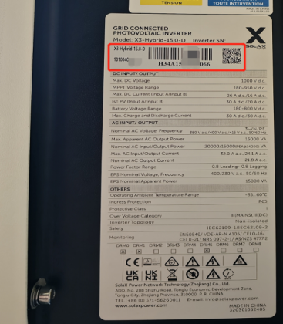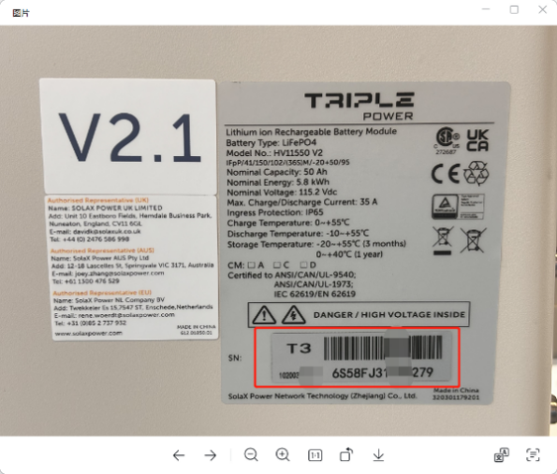
2. [Video] Progress of turning on the battery.
3. [Video] Power connection of batteries.
4. [Photo] Terminals of batteries.
X plug of T58 | Y plug of T58 | Power terminal of T30
 |  | 
5.[Photo]Voltage of batteries.
The voltage of T58 | The voltage of T30
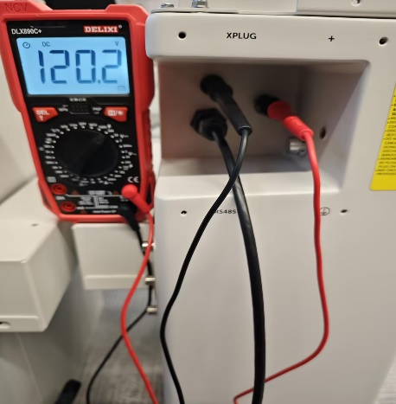 | 

